* **While loop :-**

i = 0  
 while (i<11):  
 print(i)  
 i+=1

**Output :-**

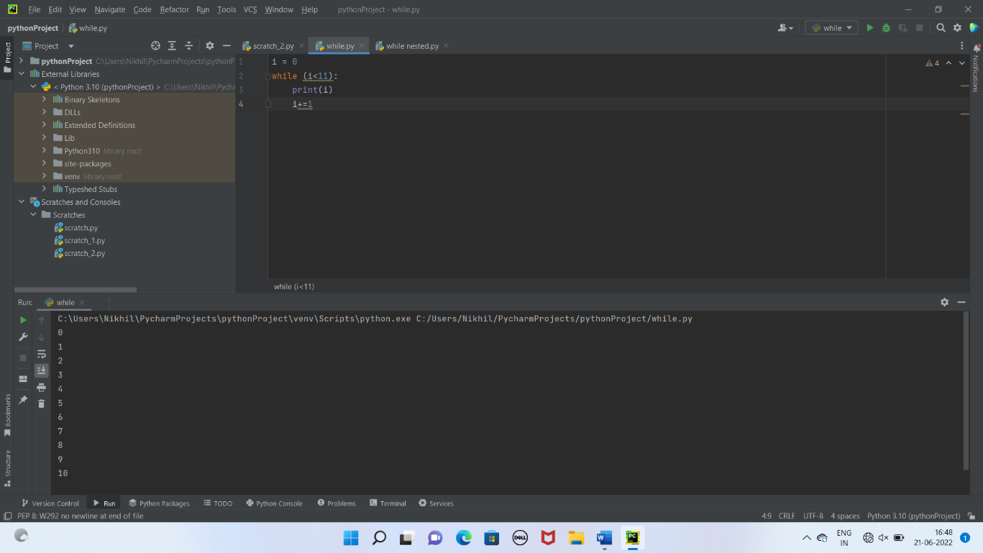

* **Nested While Loop :-**

i=1  
 while i<=4:  
 j=1  
 while j<=4:  
 print (i,"*",j,'=',i*j)  
 j+=1  
 i+=1  
 print("\n")

**Output:-**

